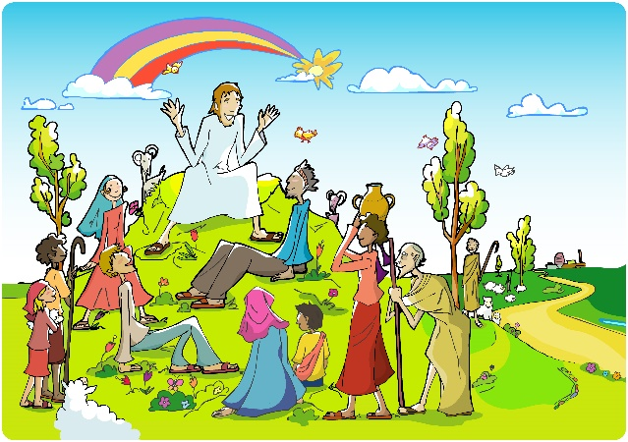
The Beatitudes

On the Sabbath Jesus taught in the synagogues. But most of the time he taught out of doors. (Summers are long and hot and dry in Israel.) Out on the hills around Lake Galilee there was plenty of room for the crowds who came to hear him. One day he sat on the grass. Lots of people sat all around him to listen.

Jesus talked about happiness.
“You think rich people are the happy ones,” he said, “because they have everything they want. But you are wrong.” Jesus looked at those sitting around him. They were poor. Some of them were hungry. But as citizens of God’s Kingdom they would have everything.
“Happy are you, poor,” Jesus said, the Kingdom of God is yours!”
“Happy are you who are hungry now; you are going to be full!
“Happy are you who cry now; you are going to laugh!
“Happy are you when people hate and reject you for being my friends. A great reward is waiting for you in heaven.”
Jesus could see that the people were puzzled. So he went on:
“Don’t try to hoard money, or buy lots of things. Someone will only steal them. Store up your treasure with God, where no one can rob you. You have to choose. Will you spend your life getting rich? Or will you do what God wants? You can’t do both.
“You are all such worriers. You worry about what you are going to eat and what you are going to wear. But there’s more to life than food and clothes. Look at the birds flying overhead. God takes care of them - and he cares much more about you!
Look around you. See how God dresses the wild flowers! Not even the famous King Solomon had clothes as beautiful as theirs. So don’t spend your life worrying. Do what God wants and he will give you all you need. You can trust God!”

Matthew 5:1-7

